**Module IV: Bluetooth and IEEE 802.15**

**4.1 To Understand Bluetooth Technology**

Bluetooth is designed to operate in an environment of many users. Up to eight devices can communicate in a small network called a piconet. Ten of these piconets can coexist in the same coverage range of the Bluetooth radio. To provide security, each link is encoded and protected against eavesdropping and interference.

**4.1.1 Discuss Bluetooth applications and architecture**

Bluetooth provides support for three general applications are using short range wireless connectivity:

1. **Data and voice access points:** Bluetooth facilitates real-time voice and data transmissions by providing effortless wireless connection of portable and stationary communications devices.
2. **Cable replacement:** Bluetooth eliminates the need for numerals, often proprietary, cable attachments for connection of practically any kind of communication device. Connections are instant and are maintained even when devices are not within line of sight. The range of each radio is approximately 10m but can be extended to 100 m with an optional amplifier.
3. **Ad hoc networking:** A device equipped with a Bluetooth radio can establish instant connection to another Bluetooth radio as soon as it comes into range.

**Application:-**

* Allows a transfer of images (or) word documents (or) applications (or) audio and video files between devices without the help of cables.

* Can be used for remote sales technology allowing wireless access to vending machines and other commercial enterprises.

* Provides inter accessibility of PDAs, palmtops and desktops for file and data exchanges.

* It can be used to setup a personal area network (PAN) or a wireless personal area network (WPAN).

**Bluetooth Standards**

Divided into two groups: core and profile.

1. The **core specifications** describe the details of the various layers of the Bluetooth protocol architecture, from the radio interface to link control. Related topics are covered, such as interoperability with related technologies, testing requirements, and a definition of various Bluetooth timers and their associated values.
2. The **profile specifications** are concerned with the use of Bluetooth technology to support various applications. Each profile specification discusses the use of the technology defined in the core specifications to implement a particular usage model. The profile specification includes a description of which aspects of the core specifications are mandatory, optional, and not applicable. The purpose of a profile specification is to define a standard of interoperability so that products from different vendors that claim to support a given usage model will work together.

**Protocol Architecture**

* Bluetooth is defined as a layered protocol architecture.
* It consisting of **core protocols**, **cable replacement** and **telephony control protocol**, and **adopted protocols**.

1. **CORE PROTOCOLS**

The **core protocols** form a five-layer stack consisting of the following elements:

1. **Radio:** Specifies details of the air interface, including frequency, the use of frequency hopping, modulation scheme, and transmit power.
2. **Baseband:** Concerned with connection establishment within a piconet, addressing, packet format, timing, and power control.
3. **Link manager protocol (LMP):** Responsible for link setup between Bluetooth devices and ongoing link management. This includes security aspects such as authentication and encryption, plus the control and negotiation of baseband packet sizes.
4. **Logical link control and adaptation protocol** (L2CA**P):** Adapts upper-layer protocols to the baseband layer. L2CAP provides both connectionless and connection-oriented services.
5. **Service discovery protocol (SDP):** Device information, services, and the characteristics of the services can be queried to enable the establishment of a connection between two or more Bluetooth devices.
6. **CABLE REPLACEMENT PROTOCOL**

* RFCOMM is the **cable replacement protocol**.
* RFCOMM presents a virtual serial port that is designed to make replacement of cable technologies as transparent as possible.
* Serial port are one of the most common types of communications interfaces used with corrupting and communications devices.
* Hence, RFCOMM enables the replacement of serial port cables with the minimum of modification of existing devices.
* RFCOMM provides for binary data transport and emulates EIA-232 control signals over the Bluetooth baseband layer.
* EIA-232 (formerly known as RS-232) is a widely) used serial port interface standard.

1. **TELEPHONY CONTROL PROTOCOL**

* Bluetooth specifies a **telephony control protocol.**
* TCS BIN (telephony control specification-binary) is a bit-oriented protocol that defines the call control signaling for the establishment of speech and data calls between Bluetooth devices.
* In addition, it defines mobility management procedures for handling groups of Bluetooth TCS devices.

1. **ADOPTED PROTOCOLS**

* The **adopted protocols** are defined in specifications issued by other standards making organizations and incorporated into the overall blue tooth architecture.
* The Bluetooth strategy is to invent only necessary protocols and use existing standards whenever possible. The adopted protocols include the following:- :

1. **PPP:** The point-to-point protocol is an Internet standard protocol for transporting **IP** datagrams over a point-to-point link.
2. **TCP/UDP/IP:** These are the foundation protocols of the *TCP/IP* protocol suite
3. **OBEX:** The object exchange protocol is a session-layer protocol developed by the Infrared Data Association (IrDA) for the exchange of objects. OBEX provides functionality similar to that of HTTP, but in a simpler fashion. It also provides a model for representing objects and operations.
4. **WAE/WAP:** Bluetooth incorporates the wireless application environment and the wireless application protocol into its architecture.

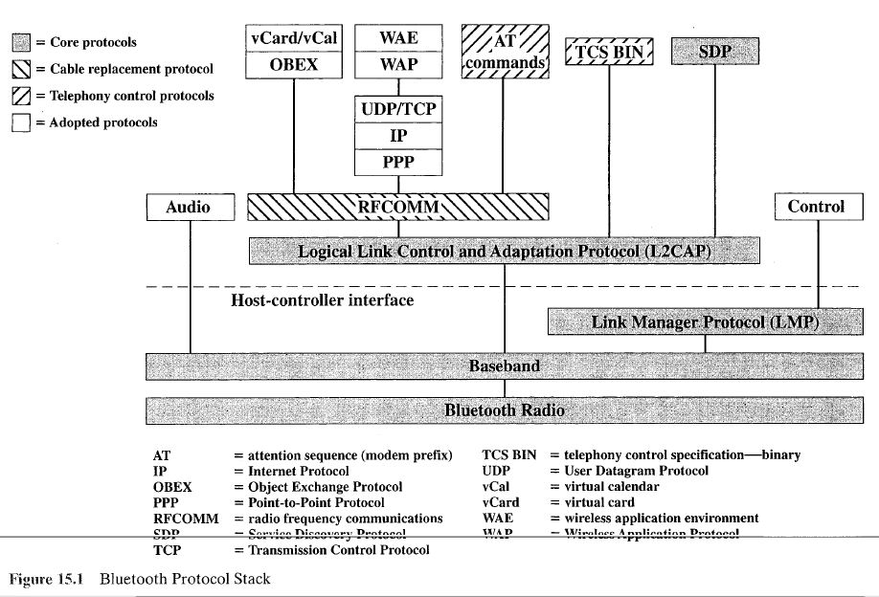

**Usage Models**

A number of usage models are defined in Bluetooth profile documents. In essence, a usage model is set of protocols that implement a particular Bluetooth-based application. Each profile defines the protocols and protocol feat res supporting a particular usage model. Figure 15.2, taken from, illustrates the highest-priority

usage models:

1. **File transfer:** The file transfer usage model supports the transfer of directories, files, documents, images, and streaming media forma s. This usage model also includes the capability to browse folders on a remote device.
2. **Internet bridge:** With this usage model, a PC is wirelessly connected to a mobile phone or cordless modern to provide dial-up networking and fax capabilities. For dial-up networking, AT commands are wed to control the mobile phone or modem, and another protocol stack (e.g., PPP over RFCOMM) is used for data transfer. For fax transfer, the fax software op rates directly over RFCOMM.
3. **LAN access**: This usage model enables devices on a piconet to access a LAN. Once connected, a device functions as if it were directly connected (wired) to the LAN.
4. **Synchronization:** This model provides a device-to-device synchronization of PIM (personal information management) information, such a phone book, calendar, message, and note information. IrMC (Ir mobile communications) is an IrDA protocol that provides a client/server capability f( r transferring updated PIM information from one device to another.
5. **Three-in-one phone**: Telephone handsets that implement thi usage model may act as a cordless phone connecting to a voice base station, s an intercom device for connecting to other telephones, and as a cellular pho e.
6. **Headset:** The headset can act as a remote device's audio inJ=ut and output interface.

**4.1.2 Explain Scatternet and Piconet**

**Piconets and Scatternets**

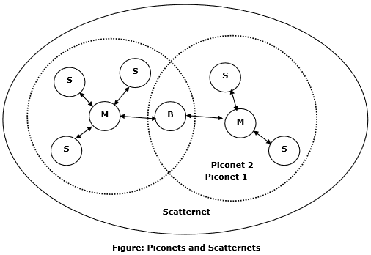

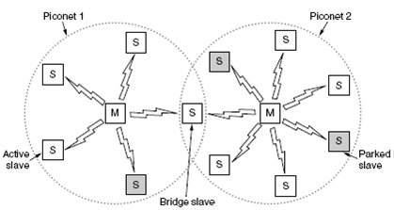

* The basic unit of networking in Bluetooth is a **piconet,** consisting of a master and from one to seven active slave devices.
* The radio designated as the master makes the determination of the channel (frequency - h opping sequence) and phase (timing offset, i.e., when to transmit) that shall be used by all devices on this piconet.
* The radio designated as master makes this determination using its Own device address as a parameter, while the slave devices must tune to the same channel and phase.
* A slave may only communicate with the master and may only communicate when granted permission by the master.
* A device in one piconet may also exist as part of another piconet and may function as either a slave or master in each piconet.This form of overlapping is called a **scatternet.**
* The advantage of the piconet/scatternet scheme is that it allows many devices to share the same physical area and make efficient use of the bandwidth.
* A Bluetooth system uses a frequency-hopping scheme with a carrier spacing of 1 MHz. Typically, up to 80 different frequencies are used for a total bandwidth of 80 MHz.
* If frequency hopping were not used, then a single channel would correspond to a single 1 MHz band.
* With frequency hopping a logical channel is defined by the frequency-hopping sequence.
* At any given time, the bandwidth available is 1 MHz, with a maximum of eight devices sharing the bandwidth.
* Different logical channels (different hopping sequences) car. simultaneously share the same 80-MHz bandwidth.
* Collisions will occur when devices in different piconets, on different logical channels, happen to use the same help frequency at the same time.
* As the number of piconets in an area increases, the number of collisions increases, and performance degrades.
* In summary, the physical area and total bandwidth are shared by the scatternet.
* The logical channel and data transfer are shared by a piconet.
* Bluetooth is designed to operate in an environment of many users.
* Up to eight devices can communicate in a small network called a **piconet.**
* Ten of these piconets can coexist in the same coverage range of the Bluetooth radio.
* To provide security, each link is encoded and protected against eavesdropping and interference.

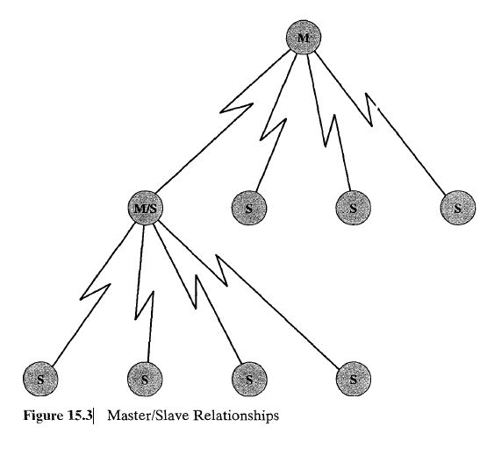

**4.2 To study about IEEE 802.15 protocol**

**4.2.1 Discuss IEEE 802.15 architecture for Wireless Personal Area Networks**

The IEEE 802.15 Working Group for Wireless Personal Area Networks (PANs) was formed to develop standards for short range wireless PANs (WPANs).A PAN is communications network within a small area in which all of the devices on the network are typically owned by one person or perhaps a family. Devices on a PAN may include portable and mobile devices, such as PCs, Personal Digital Assistants (PDAs), peripherals, cell phones, pagers, and consumer electronic devices. The first effort by the working group was to develop 802.15.1, with the goal of creating a formal standard of the Bluetooth specification; this standard was approved in 2002.

Because most or all of the planned 802.15 standards would operate in the same frequency bands as used by 802.11 devices, both the 802.11 and 802.15 working groups were concerned about the ability of these various devices to successfully coexist. The 802.15.2 Task Group was formed to develop recommended practices for coexistence. This work resulted in a recommended practices document in 2003.

Following the 802.15.1 standard, the 802.15 work went in two directions. The 802.15.3 task group is interested in developing standards for devices that are low cost and low power compared to 802.11 devices, but with significantly higher data rates than 802.15.1. An initial standard for 802.15.3 was issued in 2003 and, as of this writing, work continues on 802.15.3a, which will provide higher data rates than 802.15.3, using the same MAC layer. Meanwhile, the 802.15.4 task group developed a standard for very low cost, very low power devices at data rates lower than 802.15.1, with a standard issued in 2003.

Figure 15.17 shows the current status of the 802.15 work. Each of the three wireless PAN standards has not only different physical layer specifications but different requirements for the MAC layer. Accordingly, each has a unique MAC specification. Figure 15.18, based on one in [ZHEN04], gives an indication of the relative scope of application of the wireless LAN and PAN standards. As can be seen, the 802.15 wireless PAN standards are intended for very short range, up to about 10 m, which enables the use of low power, low cost devices.

This section provides an overview of 802.15.3 and 802.15.4.

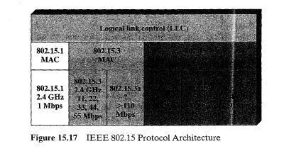

* + 1. **Explain IEEE 802.15.3 protocol for WPAN**

**IEEE 802.15.3**

The 802.15.3 task group is concerned with the development of high data rate WPANs. Examples of applications that would fit a WPAN profile but would also require a relatively high data rate include

Connecting digital still cameras to printers or kiosks

• Laptop to projector connection

• Connecting a personal digital assistant (PDA) to a camera or PDA to a printer

• Speakers in a 5:1 surround-sound system connecting to the receiver

• Video distribution from a set-top box or cable modem

• Sending music from a CD or MP3 player to headphones or speakers

• Video camera display on television

• Remote view finders for video or digital still cameras

These applications are mainly in the consumer electronics area and generate

the following requirements:

• **Short range:** On the order of 10m.

• **High throughput**: Greater than 20 Mbps to support video and/or multichannel

audio.

• **Low power usage:** To be useful in battery-powered portable devices.

• **Low cost**: To be reasonable for inexpensive consumer electronic devices.

**• QoS (quality of service) capable**: To provide guaranteed data rate and other OoS features for applications sensitive to throughput or latency.

• **Dynamic environment:** Refers to a piconet architecture in which mobile,portable, and stationary devices enter and leave the piconet often. For mobile device, a speed of less than 7 kilometers per hour is addressed.

• **Simple connectivity:** To make networking easy and eliminate the need for a technically sophisticated user.

• **Privacy:** To assure the user that only the intended recipients can understand what is being transmitted.

* + 1. **Describe Bluetooth low energy.**

**Bluetooth Low Energy** (**Bluetooth LE**, BLE, formerly marketed as **Bluetooth**Smart) is a wireless personal area network **technology** designed and marketed by the **Bluetooth** Special Interest Group aimed at novel applications in the healthcare, fitness, beacons, security, and home entertainment industries.

Comparison table for Bluetooth ranges:

|  |  |  |
| --- | --- | --- |
|  | **Bluetooth v2.1** | **Bluetooth low energy (BLE)** |
| Range | up to 100 meters | up to 100 meters |
| Max Range (free field) | Around 100 m (class 2 outdoors) | Around 100 m (outdoors) |
| Frequency | 2.402 – 2.481 GHz | 2.402 – 2.481 GHz |
| Max data rate | 1-3 Mbit/s | 1 Mbit/s |

* + 1. **Discuss Wireless Sensor Network**

Wireless sensor network (WSN) refers to a group of spatially dispersed and dedicated sensors for monitoring and recording the physical conditions of the environment and organizing the collected data at a central location. WSNs measure environmental conditions like temperature, sound, pollution levels, humidity, wind, and so on.

These are similar to [wireless ad hoc networks](https://en.wikipedia.org/wiki/Wireless_ad_hoc_network) in the sense that they rely on wireless connectivity and spontaneous formation of networks so that sensor data can be transported wirelessly. WSNs are spatially distributed [autonomous](https://en.wikipedia.org/wiki/Autonomous) [sensors](https://en.wikipedia.org/wiki/Sensor) to *monitor* physical or environmental conditions, such as [temperature](https://en.wikipedia.org/wiki/Temperature), [sound](https://en.wikipedia.org/wiki/Sound), [pressure](https://en.wikipedia.org/wiki/Pressure), etc. and to cooperatively pass their data through the network to a main location. The more modern networks are bi-directional, also enabling *control* of sensor activity. The development of

wireless sensor networks was motivated by military applications such as battlefield surveillance; today such networks are used in many industrial and consumer applications, such as industrial process monitoring and control, machine health monitoring, and so on

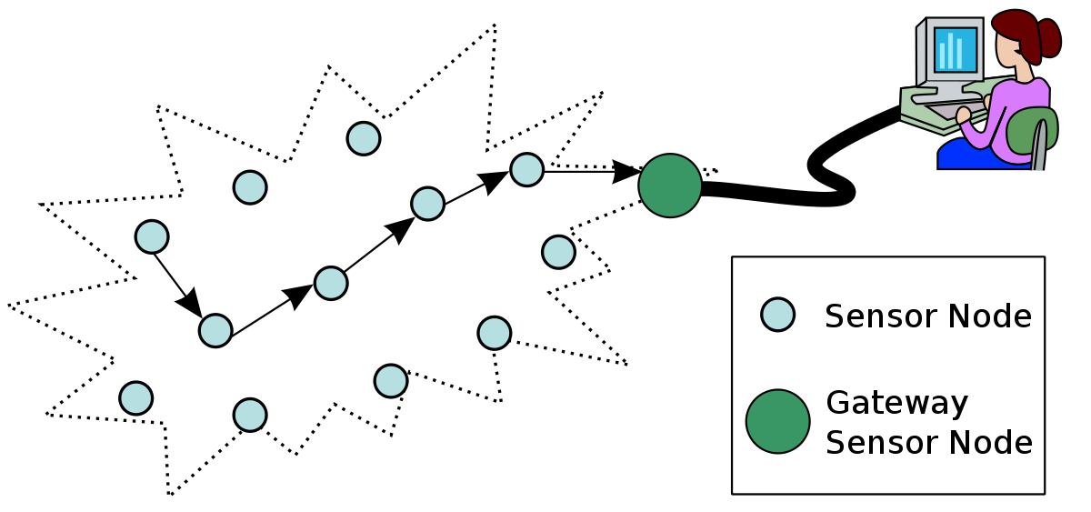

A Sensor is a device that responds and detects some type of input from both the physical or environmental conditions, such as pressure, heat, light, etc. The output of the sensor is generally an electrical signal that is transmitted to a controller for further processing. A Wireless sensor network can be defined as a network of devices that can communicate the information gathered from a monitored field through wireless links. The data is forwarded through multiple nodes, and with a gateway, the data is connected to other networks like [wireless Ethernet](https://www.elprocus.com/what-is-ethernet-and-different-types-of-ethernet-networks/).

### WSN Network Topologies

For radio communication networks, the structure of a WSN includes various topologies like the ones given below.

[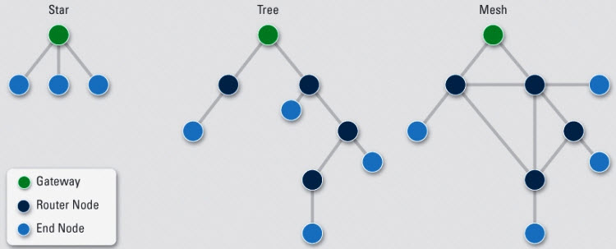](https://www.elprocus.com/wp-content/uploads/2014/03/28.jpg)

### Types of WSNs (Wireless Sensor Networks)

Depending on the environment, the [types of networks](https://www.elprocus.com/important-of-network-in-embedded-systems-for-beginners/) are decided so that those can be deployed underwater, underground, on land, and so on. Different types of WSNs include:

1. Terrestrial WSNs
2. Underground WSNs
3. Underwater WSNs
4. Multimedia WSNs
5. Mobile WSNs

#### 1. Terrestrial WSNs

Terrestrial WSNs are capable of communicating base stations efficiently, and consist of hundreds to thousands of wireless sensor nodes deployed either in unstructured (ad hoc) or structured (Preplanned) manner. In an unstructured mode, the sensor nodes are randomly distributed within the target area that is dropped from a fixed plane. The preplanned or structured mode considers optimal placement, grid placement, and 2D, 3D placement models.

In this WSN, the [battery power](https://www.elprocus.com/battery-charger-timer-tips/) is limited; however, the battery is equipped with solar cells as a secondary power source. The Energy conservation of these WSNs is achieved by using low duty cycle operations, minimizing delays, and optimal routing, and so on.

#### 2. Underground WSNs

The underground wireless sensor networks are more expensive than the terrestrial WSNs in terms of deployment, maintenance, and equipment cost considerations and careful planning. The WSNs networks consist of a number of sensor nodes that are hidden in the ground to monitor underground conditions. To relay information from the sensor nodes to the base station, additional sink nodes are located above the ground.

[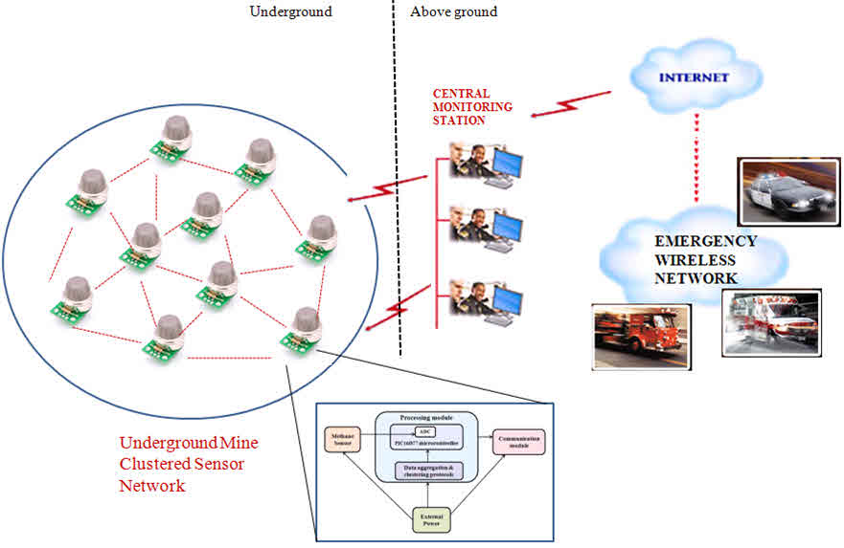](https://www.elprocus.com/wp-content/uploads/2014/03/38.jpg)

The underground wireless sensor networks deployed into the ground are difficult to recharge. The sensor battery nodes equipped with a limited battery power are difficult to recharge. In addition to this, the underground environment makes wireless communication a challenge due to high level of attenuation and signal loss.

#### 3. Under Water WSNs

More than 70% of the earth is occupied with water. These networks consist of a number of sensor nodes and vehicles deployed under water. Autonomous underwater vehicles are used for gathering data from these sensor nodes. A challenge of underwater communication is a long propagation delay, and bandwidth and sensor failures.

[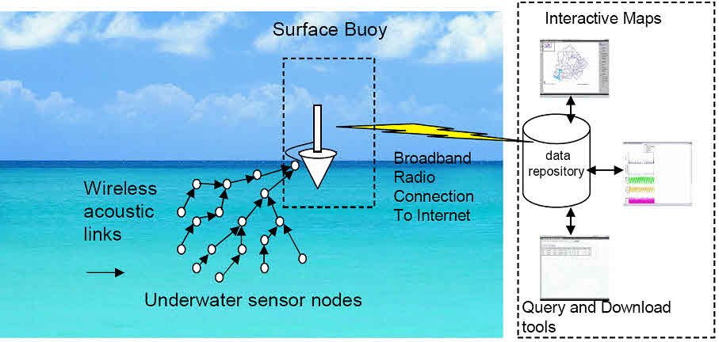](https://www.elprocus.com/wp-content/uploads/2014/03/49.jpg)

#### 4. Multimedia WSNs

Muttimedia wireless sensor networks have been proposed to enable tracking and monitoring of events in the form of multimedia, such as imaging, video, and audio. These networks consist of low-cost sensor nodes equipped with micrpphones and cameras.These nodes are interconnected with each other over a wireless connection for data compression, data retrieval and correlation.

[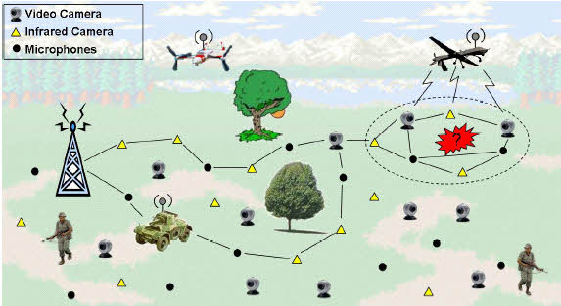](https://www.elprocus.com/wp-content/uploads/2014/03/58.jpg)

#### 5. Mobile WSNs

These networks consist of a collection of sensor nodes that can be moved on their own and can be interacted with the physical environment. The mobile nodes have the ability to compute sense and communicate.

### Limitations of Wireless Sensor Networks

1. Possess very little storage capacity – a few hundred kilobytes
2. Possess modest processing power-8MHz
3. Works in short communication range – consumes a lot of power
4. Requires minimal energy – constrains protocols
5. Have batteries with a finite life time
6. Passive devices provide little energy

### Wireless Sensor Networks Applications

[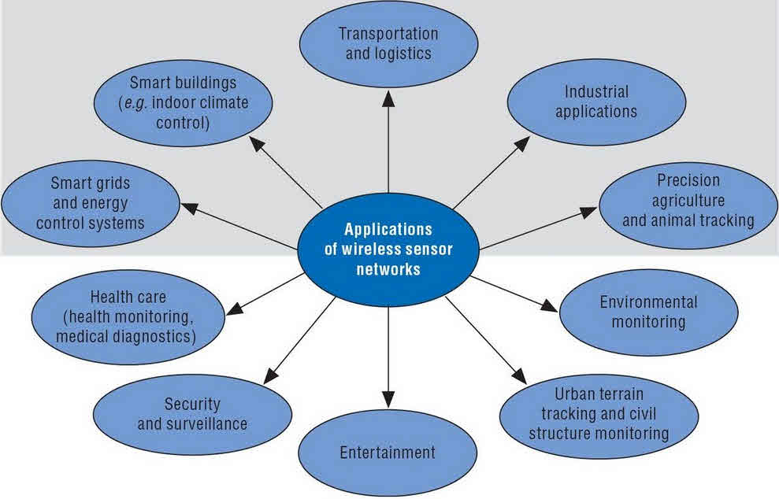](https://www.elprocus.com/wp-content/uploads/2014/03/63.jpg)